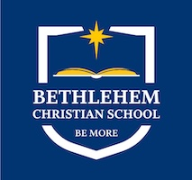
2025-2026
Supply List
Middle School/High School (7th-12th)

- Bible-NIV
- Supply of #2 pencils
- Pencil bag
- 2 Sturdy erasers
- Blue or Black ballpoint pens
- 3x5 spiral note cards
- Loose leaf (3 ring, college ruled) notebook paper
- Calculator-T1-30 series (labeled with name on cover)
- Notebook/Folders/Binders
- 2” binder (Math and English)
- Highlighters
- Media storage device-memory stick
- Sharpies (Art)
- 5x7 spiral bound sketch book (Art)
- Fine Liner Pens - sizes 005-08 (Art)
- Apron or T-shirt (stored in class for painting days)

